

PROPOSAL DOCUMENT

Vulnerability Assessment &
Penetration Testing (VAPT) Report

Ambledown Financial Services (PTY) Ltd

18 October 2023
© Sautech (Pty) Ltd. http://www.sautech.net

TABLE OF CONTENTS

1 Executive summary 3
2 scope of testing 3
3 Methodologies used 3
3.1 Nmap / Zenmap 3
3.2 Nessus 3
3.3 Greenbone Enterprise 4
4 Stay One Step Ahead of Attackers 4
4.1 OWASP 5
4.2 BRUTE FORCE 5
4.3 Applications used in Brute Force Include: 5
5 Infrastucture 6
5.1 Afrihost Server – 154.0.171.224 6
5.2 Data Keepers Server – 102.67.139.234 8
5.3 Firewall – Head Office Port Forwards – 41.169.103.84 10
5.4 Active Directory / VPN Server 11
5.5 FortiGate Firewall Rules. 12
5.6 Wireless Network. 13
6 Reporting Conclusion 13
7 Auditors 14

Executive summary

The purpose of this assessment was to point out security loopholes, business logic errors, and missing best security practices. The tests were carried out assuming the identity of an attacker or a malicious user but, no harm was made to the functionality or working of the application / network. A full scan was also performed on the infrastructure to demonstrate a known attack, i.e. someone on the internal network or same public subnetted infrastructure. The scans and brute force were performed over 11 (eleven) business days, as full and slow comprehensive audits were performed. These types of scans also look at unknown connectivity options, including packet SYN requests.

The overall results will be published below, High-level, Sautech is comfortable and happy with the results. Some recommendations however, is offered and also mentioned throughout this document.

scope of testing

Security assessments include testing for security loopholes in the scope defined below. Apart from the following, no other information was provided. Nothing was assumed at the start of the security assessment. The following scope of servers were covered under the security audit:

- Server hosted at Afrihost - 154.0.171.224
- Server hosted at DataKeepers – 102.67.139.234
- Firewall at Head Office and associated Port Forwards – 41.169.103.84
- Active Directory Policies
- FortiGate Firewall Rules
- Wireless Network Security

Methodologies used

Sautech performed various audit techniques that includes the following:

Nmap / Zenmap

Nmap, short for Network Mapper, is a free and open source tool used for vulnerability checking, port scanning and, of course, network mapping. Despite being created back in 1997, Nmap remains the gold standard against which all other similar tools either commercial or open source, are judged.

To deploy Nmap, users originally had to have some advanced programming skills, with the introduction of the Zenmap tool for Nmap, which adds a graphical interface that makes launching the program and analysing the returned output it generates much more accessible.

Nessus

Nessus is a remote security scanning tool, which scans a computer and raises an alert if it discovers any vulnerabilities that malicious hackers could use to gain access to any computer you have connected to a network. It does this by running over 1200 checks on a given computer, testing to see if any of these attacks could be used to break into the computer or otherwise harm it.

Greenbone Enterprise
Greenbone is the world’s most widely used vulnerability management provider.

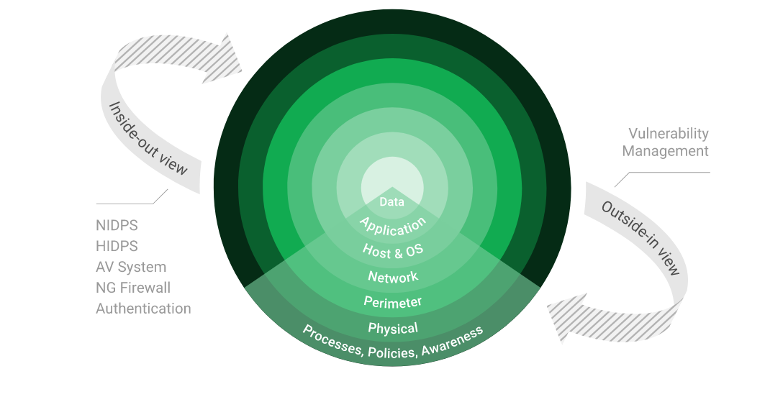

Stay One Step Ahead of Attackers
IT security is a process – Open Source vulnerability management provides the foundation. Once you know where the chinks are in your armor, you can do something about them.

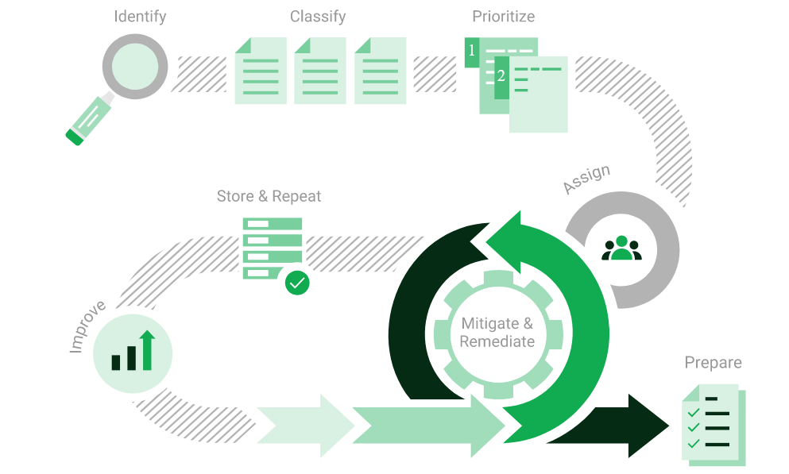

The process – from recognition to remedy and monitoring – represents a continuous cycle. You’ll always be one step ahead of attackers.

OWASP

The Open Web Application Security Project (OWASP) is an online community that produces freely-available articles, methodologies, documentation, tools, and technologies in the field of web application security. The Open Web Application Security Project (OWASP) provides free and open resources. It is led by a non-profit called The OWASP Foundation. The OWASP Top 10 - 2021 is the published result of recent research based on comprehensive data compiled from over 40 partner organizations.

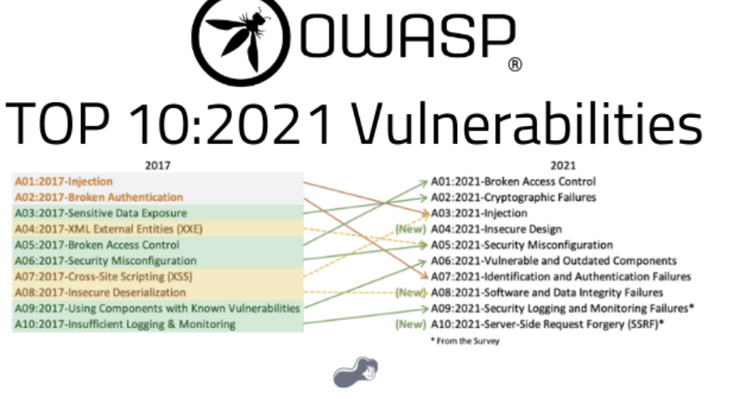

BRUTE FORCE

- A brute force attack is a hacking method that uses trial and error to crack passwords, login credentials, and encryption keys. It is a simple yet reliable tactic for gaining unauthorized access to individual accounts and organizations’ systems and networks. The hacker tries multiple usernames and passwords, often using a computer to test a wide range of combinations, until they find the correct login information.

- The name "brute force" comes from attackers using excessively forceful attempts to gain access to user accounts. Despite being an old cyberattack method, brute force attacks are tried and tested and remain a popular tactic with hackers

Applications used in Brute Force Include:

Hydra is a parallelized network login cracker built in various operating systems like Kali Linux, Parrot and other major penetration testing environments. Hydra works by using different approaches to perform brute-force attacks in order to guess the right username and password combination. Hydra is commonly used by penetration testers together with a set of programmes like crunch,[2] cupp[3] etc, which are used to generate wordlists. Hydra is then used to test the attacks using the wordlists that these programmes created.

Over 1 Million + Username and password combos are used to Brute force application like RDP, SSH etc.

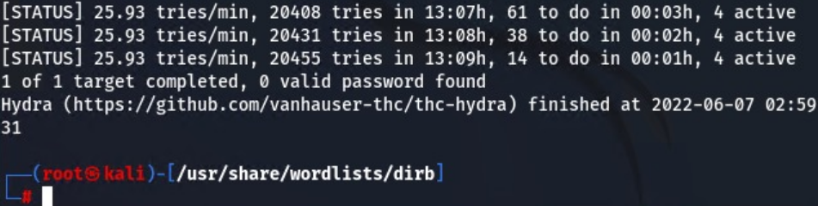

Infrastucture

Afrihost Server – 154.0.171.224

We have performed three types of scans / attacks on the production server namely:

- Port Mapping (Open / Exposed Services) These were performed from unknown and known locations to test not just the security from the perimeter, but also include local network. Based on the port mapping open access to Public and Private, selected coordinated assessments were performed specific to the open connectivity received.
- Vulnerability Assessments.
- Bruce Force Attacks.

Port Mapping

Nmap can be used by hackers to gain access to uncontrolled ports on a system. All a hacker would need to do to successfully get into a targeted system would be to run Nmap on that system, look for vulnerabilities, and figure out how to exploit them.

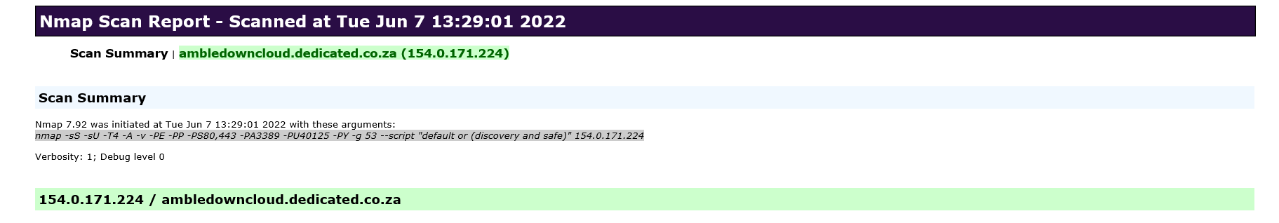
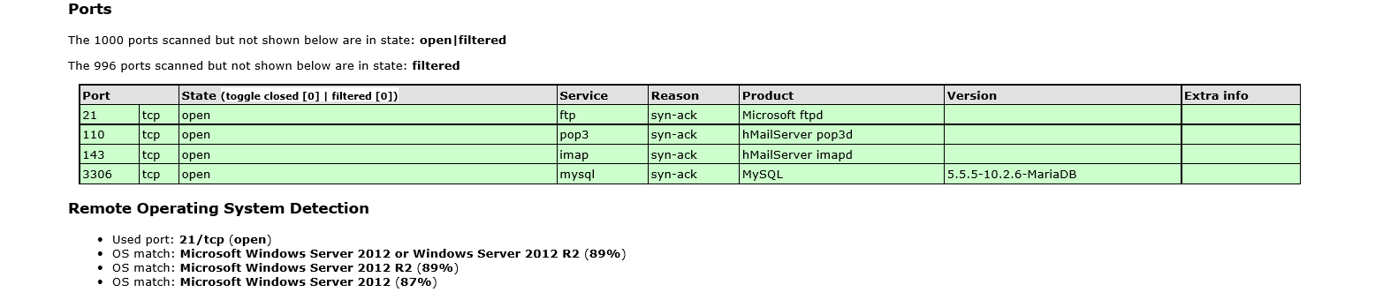

As detected above, Windows 2012 is being used on the server. As per the Microsoft support lifecycle, the extended support/update release will end October 2023. It is highly recommended to upgrade to a Later version OS as soon as possible.

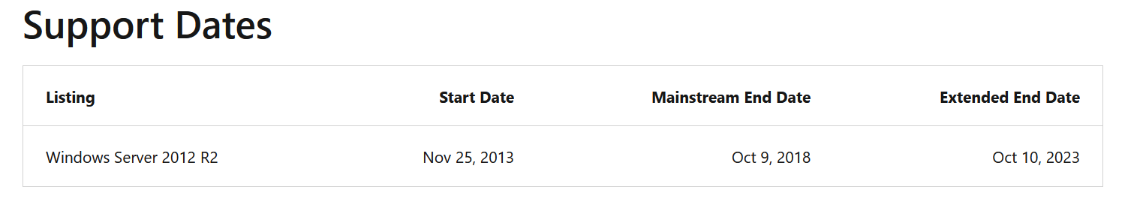

Vulnerability Assessment
Multiple technologies were used to perform a vulnerability assessment, below is the summarised version of the relevant results:

We have attached the below “highlight” in a separate report so that you can click on the “Plugin” link to get the resolution.

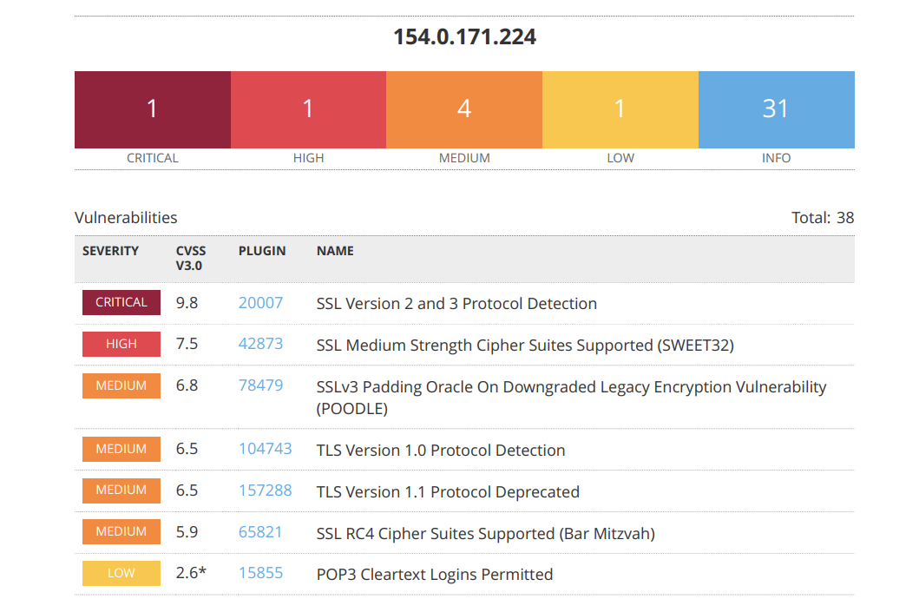

Brute Force
Randomised usernames with a word list containing more than 1+ million words and common passwords were brute forced SSH’s onto the server using Hydra.

Hydra works by using different approaches to perform brute-force attacks in order to guess the right username and password combination. Hydra is commonly used by penetration testers together with a set of programmes like crunch, cupp etc, which are used to generate wordlists.

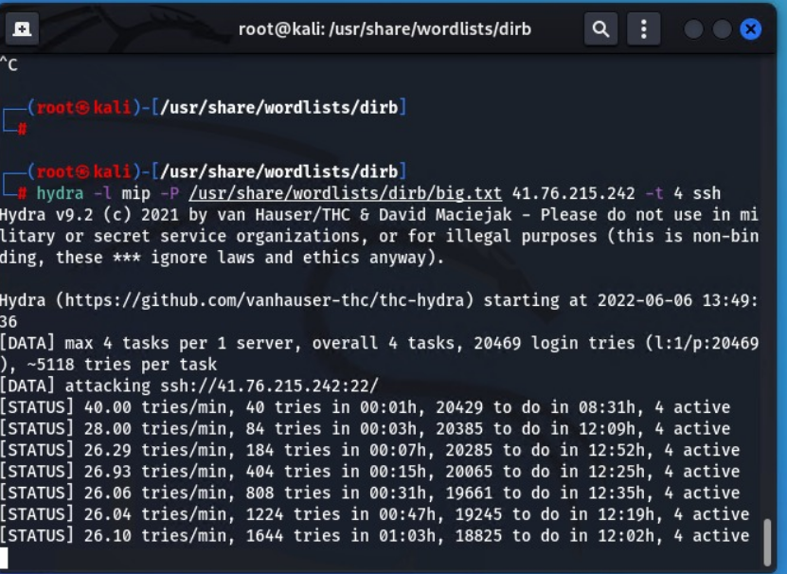

Data Keepers Server – 102.67.139.234

We have performed three types of scans/attacks on the production server namely:
- Port Mapping (Open / Exposed Services) These were performed from unknown and known locations to test not just the security from the perimeter but also include local network.
- Vulnerability assessments
- Bruce Force Attacks

Port Mapping
Nmap can be used by hackers to gain access to uncontrolled ports on a system. All a hacker would need to do to successfully get into a targeted system would be to run Nmap on that system, look for vulnerabilities, and figure out how to exploit them.

The below screenshot demonstrates the open network port mapping:

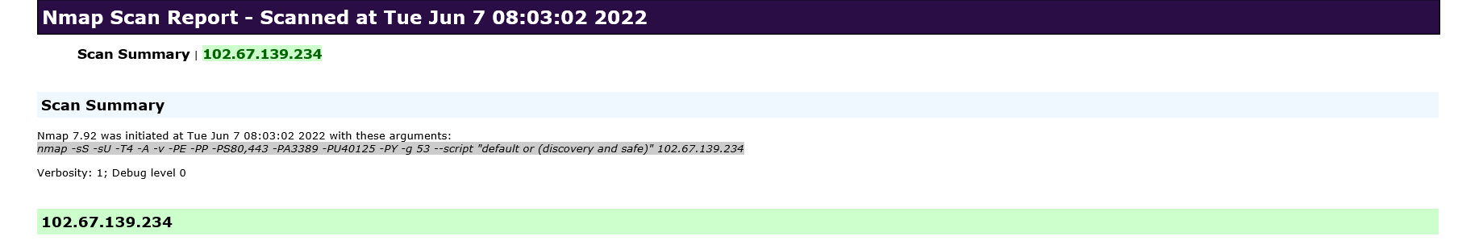

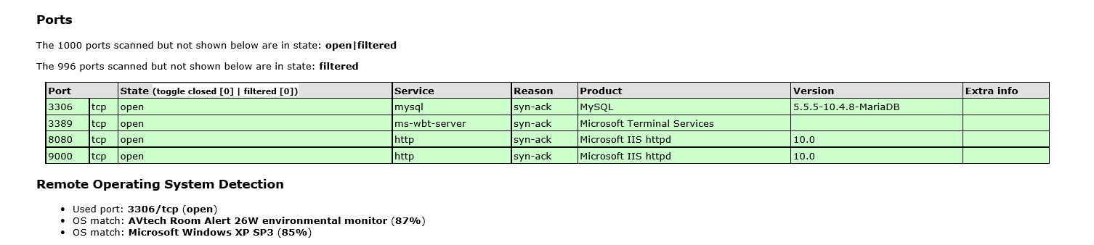

We Recommend closing RDP (3389) or either of the following perform RDP is Accessed

- VPN with Certicate (not username and password combination)
- Configure Local Firewall to only accept RDP connections from known source address
- Install 2FA i.e. Google Authenticator.

Vulnerability Assessment

Multiple technologies were used to perform a vulnerability assessment, below is the summarised version of the relevant results:

We have attached the below “highlight” in a separate report so that you can click on the “Plugin” link to get the resolution.

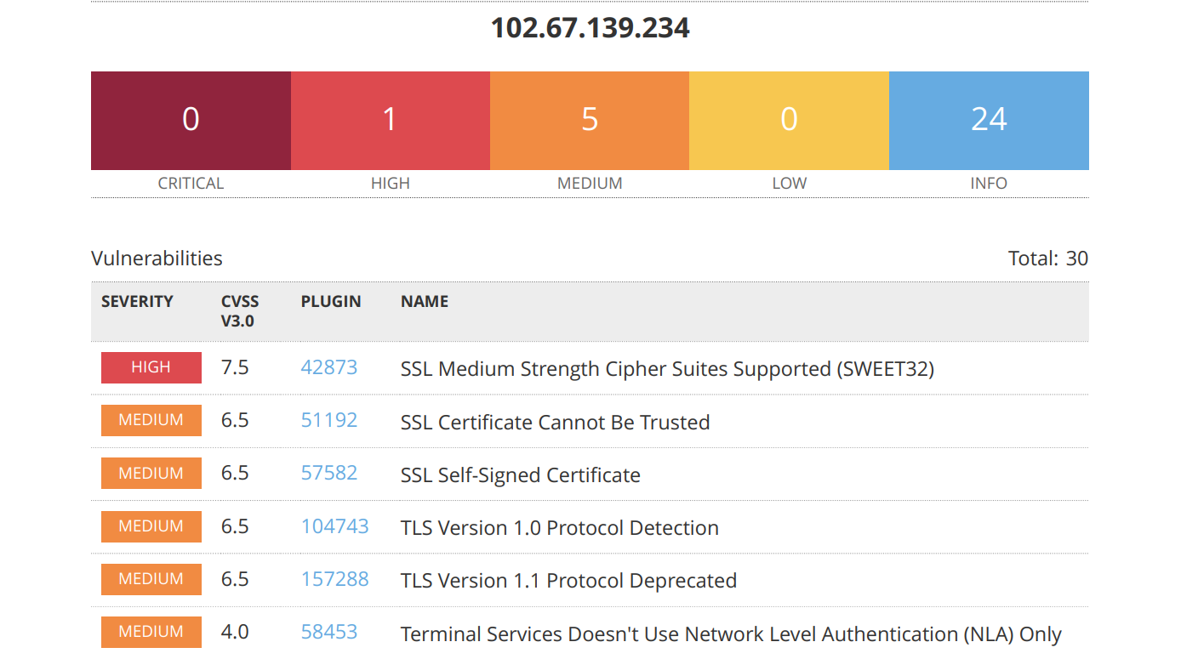

Firewall – Head Office Port Forwards – 41.169.103.84

Port Mapping

Nmap can be used by hackers to gain access to uncontrolled ports on a system. All a hacker would need to do to successfully get into a targeted system would be to run Nmap on that system, look for vulnerabilities, and figure out how to exploit them.

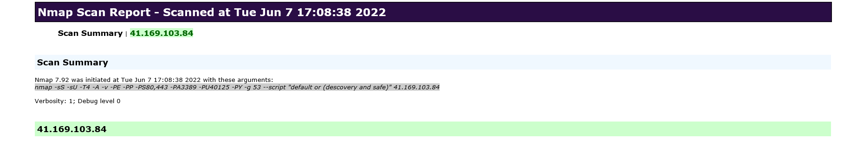

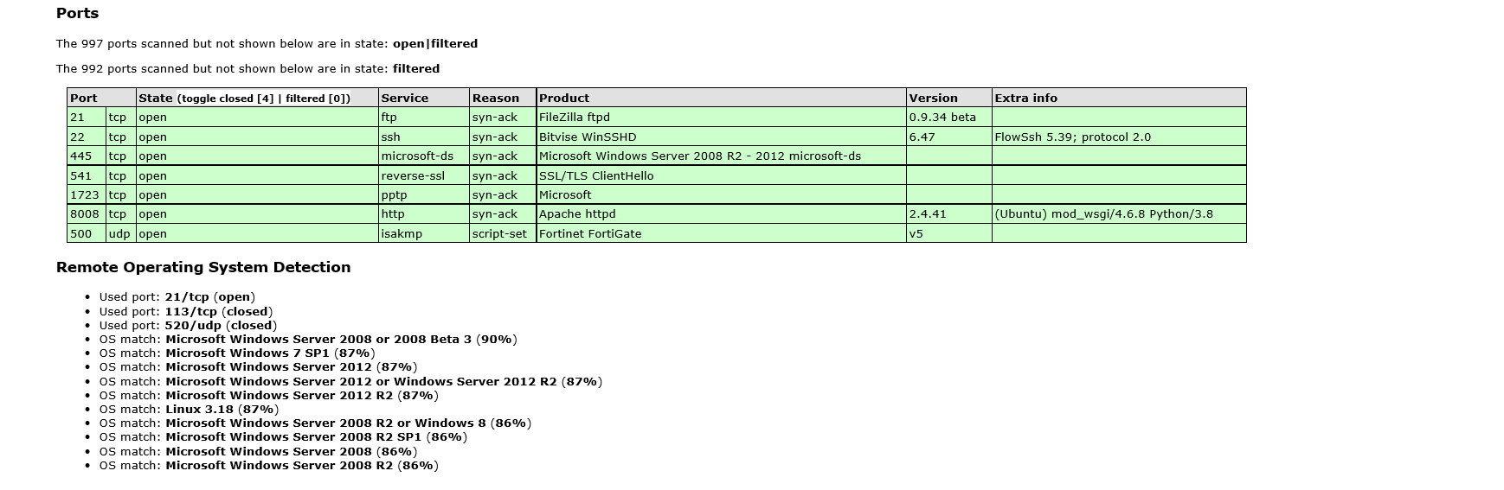

Vulnerability Assessment
Multiple technologies were used to perform a vulnerability assessment, below is the summarised version of the relevant results:

We have attached the below “highlight” in a separate report so that you can click on the “Plugin” link to get the resolution.

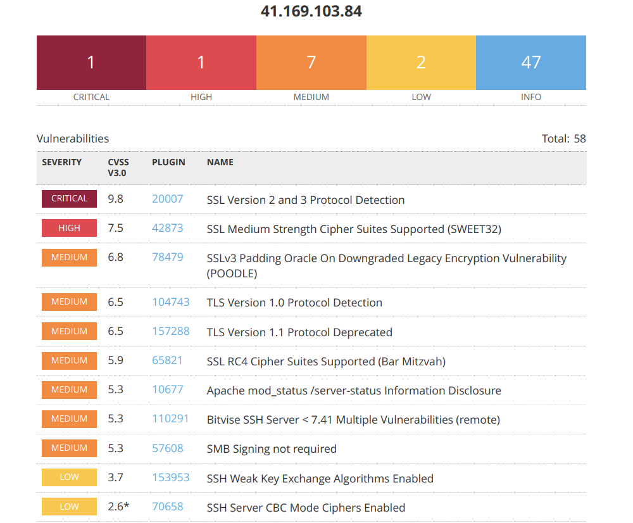

Active Directory / VPN Server

The Active Directory analysis was performed onsite with our team and a couple of items to note below:

- Password Policies
- Complexity and known passwords we are comfortable with, we will however recommend extending the password length from 8 – 14 characters
- Password lockout option is disabled, we recommend enabling this. This is what happens when there is no lockout policy, within time, the password will be brute forced: (picture below is taken within a 40 second time span)

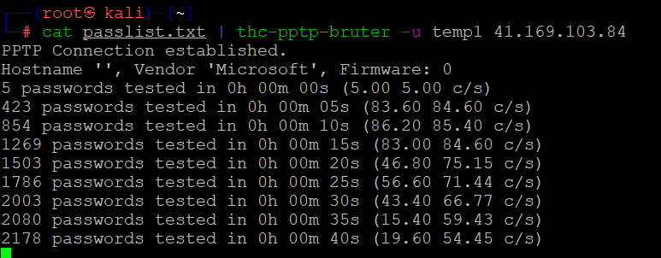

- Domain account rename from administrator to something arbitrary “mainuser” Because of this, we were able to retrieve the password hash with Wireshark

- Windows Server 2008 is used and there is no more support or updates to this software, upgrade to newer version as a matter of urgency
- Local firewall is disabled, enable and only allow services that is needed
- No Anti-Virus was detected or installed on the AD Server – Critical
- Consider changing the VPN from user/pass based authentication to user/cert-based authentication
- We have not gone through internal policies for user creating/deletion etc, but noticed a lot of “test” user accounts connecting via VPN. These are the first accounts hackers use together with administrator/admin guest to brute force accounts.

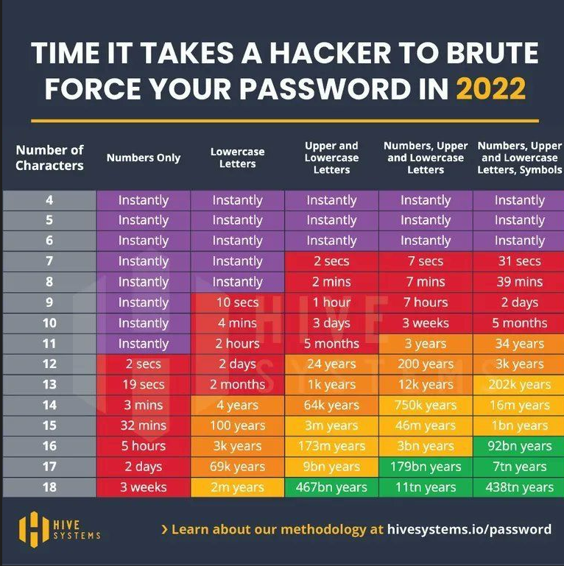

FortiGate Firewall Rules.

For Security reasons, we will not paste the firewall rules here, this can be obtained manually if need be.

We have only analysed the inbound rules as was the mandate and did not evaluate outbound, IPS or user policies. When we tried to login to the firewall, we were happy to note that entering the wrong password three times. We are also happy to know that the Web UI interface is not accessible via browser externally.

We cannot comment on rules created and why it’s needed or not, but we do note there might be some rules that is old/outdated/not needed anymore. Although they pose no direct risk, we would disable/delete what is not needed.

On the rest of the firewall configuration, we are comfortable.

Wireless Network

We performed a wireless network scan/attack from Kali Linux.
The SSID should be hidden as its easy identifiable by name to which company it belongs and we could then detect easily what Encryption was used. Based on the encryption we knew the amount of characters that will be maximum and scanned the wireless network password.

Please consider changing the password to more Upper/lower/numeric/Symbolic Combinations.
Also, please consider when the SSID is hidden, to install a guest WIFI off the main network, separate Vlan with breakout.

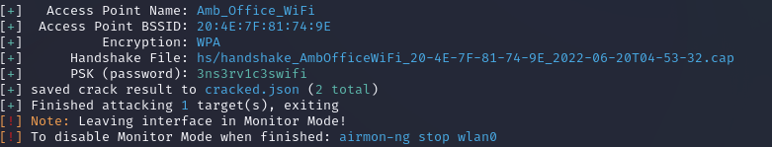

Reporting Conclusion

Based on the OWASP reports it is best to attach these separate to the reporting document. These reports can then be shared with the relevant contractors and/or support personnel to implement the changes and updates.

It is our view that from External Testing where the SSH port are not open to public, these vulnerabilities then become academic. However, we still recommend that the changes be implemented. Ambledown Financial Services is behind the managed FortiGate firewall.

The HTTPS updates as these are open to the public, low and medium risk, should be tested and implemented as soon as possible.

From a Hosted Infrastructure point of view, we are happy with the results. We do recommend that SenitnelOne is implemented into the production environment as soon as possible.
We also recommend where Operating systems are end of life or close to, they be upgraded.

Six addendum reports are attached to this report and should be read as one document.

With the following test performed:

- Network scanning
- IDS/IPS disabled
- Knows network attack (from Internet to the FW)
- External HTTP and Port exploits
- Vulnerability assessment on CVE
- Penetration testing on login ports i.e.: ssh open

.

Auditors

These audits were concluded over a period of 15 days.
We hereby confirm that the above information is true and correct:

27th June 2022 – Krugersdorp, South Africa

_________________________ _________________________
Riaan van Jaarsveld Lukas Janse van Rensburg
Security Expert – CCSA Security Engineer

